mid lab .SDA

Name: shoaib sakhawat

Reg no: sp23-bse-135

1. **Draw a USE CASE Diagram on the Page with your Name and Registration number on it**

**Use case diagrams:**

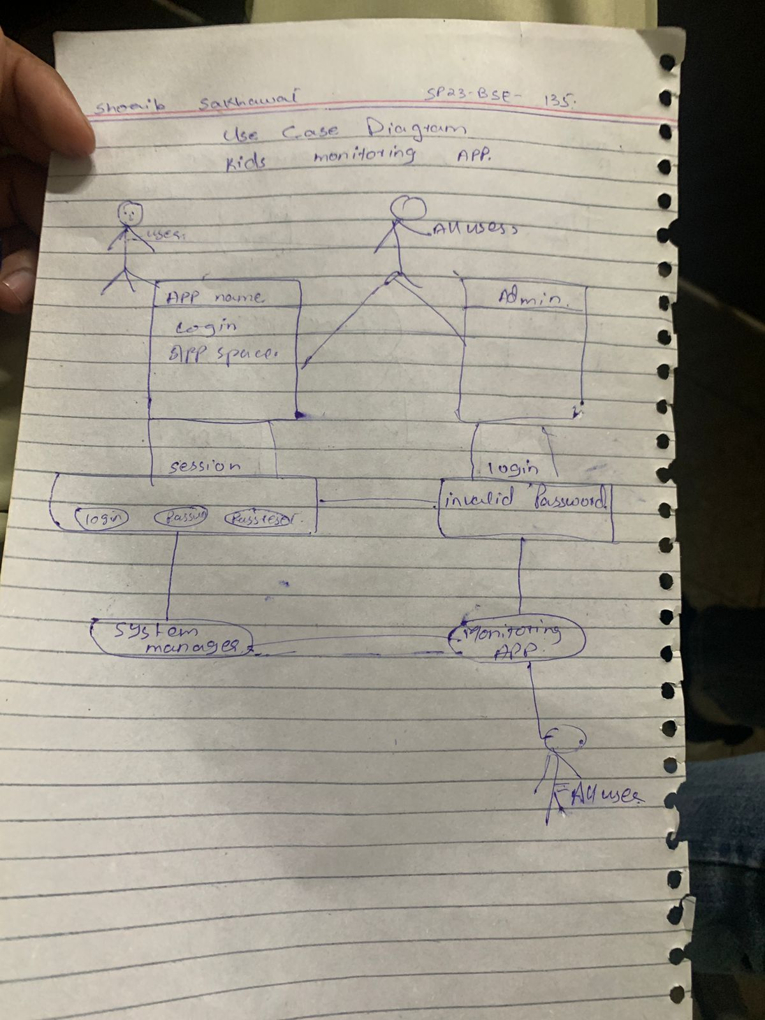

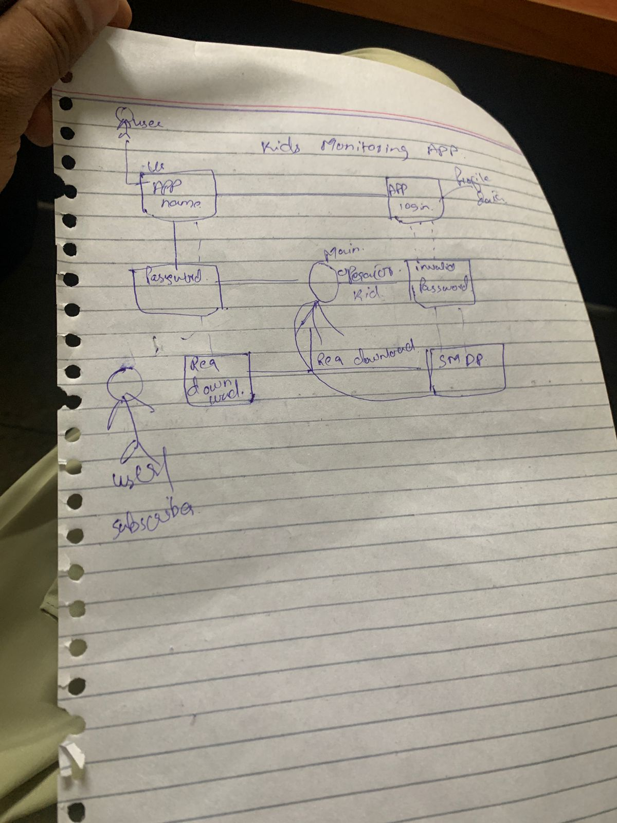

**1. Model-View-Controller (MVC) Pattern**

* **Why:** This pattern separates the user interface (View), business logic (Controller), and data (Model), which makes the system modular and easier to maintain.
* **Application:** The login screens (View), session handling (Controller), and user data (Model) can be handled separately.

**2. Single Responsibility Principle (SRP) – [SOLID Principle]**

* **Why:** Each class or module should have only one reason to change.
* **Application:** Separate classes for handling login, monitoring, session management, etc.

**3. Observer Pattern**

* **Why:** Useful in monitoring apps where changes (e.g., kid activity updates) need to be observed and acted upon.
* **Application:** Admin can be notified in real-time if any suspicious activity is detected.